Cameron Pickle

1. You have just been hired at the famous company WSB.com (Weber State Books) which sells books over the Internet. They have been having problems with their database designs and have hired you as a database expert to help fix them. The Figure below shows a Conceptual Entity Relationship diagram intended to represent WSB.com’s main database to track sales of books to customers. Note: Customers belong to “clubs”, such as ACM, student, professor, alumni, and so forth. There can be several “offers” available for a book which determines its price based upon the clubs to which a customer belongs.

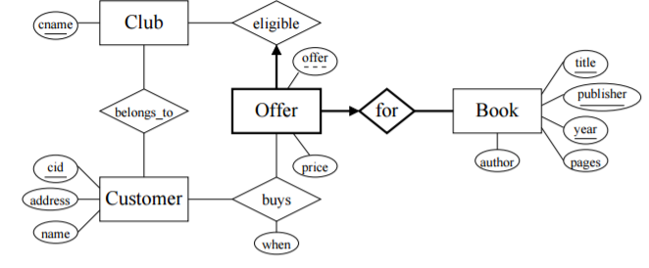

**Based on the above Figure, answer the following questions (in as much detail as possible)….**

1. How does one determine the price a given customer paid for a given book?
   1. What small correction needs to be made to the E-R diagram to capture this data correctly?

Currently it is not possible to tell how much a customer paid for a given book. There is only a table that shows the different offer prices available to each customer but not a table that shows purchases. To fix this problem we need to add a purchase table so we can look at a specific purchase transaction to see how much a customer paid for a given book.

1. Is it possible for two customers to buy the same book but for different prices?
   1. If so, how is this possible? If not, how does the logic of the E-R diagram prohibit this?

No, in this diagram it shows that the customer can only belong to a single club and that club has its offered price for the book.

1. Does the customer always pay the lowest price for which he or she is eligible?
   1. If not, is there an easy way to modify the E-R diagram in order to assure this?

No it is not guaranteed. I do not know of any way to guarantee that the customer always pays the lowest price just through the database design.

1. Does the E-R diagram ensure that the Offer under which a customer buys a book is, in fact, legitimate? That is, an offer is for a particular club’s members. Are we guaranteed that the customer belongs to the corresponding club? Why or why not?

Not as currently shown. The buy relationship between customer and offer needs to be removed because it is an illegitimate way to purchase a book. Once that relationship is removed it is guaranteed that the customer belongs to the corresponding club because they must go through the club table to get the offer.

1. **The Fix**

Consider again WSB.com’s database.

1. There is a serious flaw (at least one) in the design in the figure above, at least in as far as any bookseller would be concerned. What is the flaw?

The bookseller cannot track how many purchases of a book have occurred. There is no transactional history being stored anywhere in the database. There is currently only relationships between customers, the clubs they belong to and the offer that each of those clubs have for a book.

1. Redesign the E-R Diagram to fix this. Save the readable image and embed it back into this document.

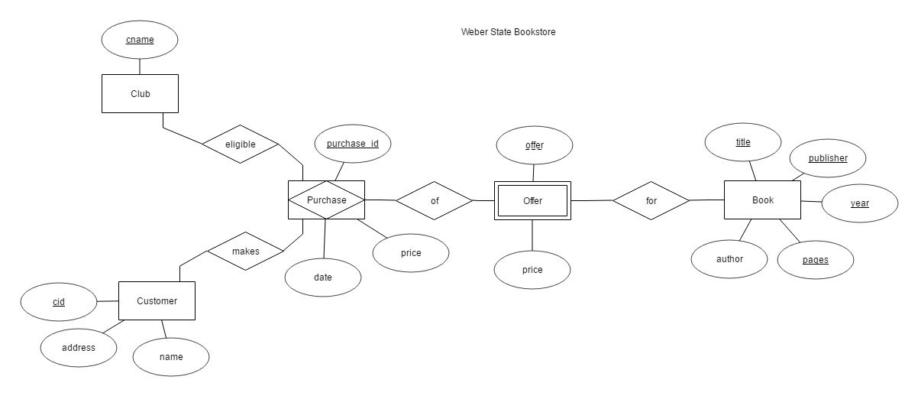

1. **Create a Conceptual Diagram (electronically) for the following scenario - LEAVING the Many to Many relationships and identifying the major attributes. Save the readable image and embed it back into this document.**

Weber State University has secured funds to run a local radio station called WEBR for approximately one month a year. The administrator in charge of the venture wishes to collect information for a variety of reasons:

* Contact list of various types of people for the next season
* Billing and expenditure
* Activities including listings for each program
* Studio booking
* Equipment booking

The radio station has a core staff of four: a producer /director, manager, recording engineer (part time) and a secretary. Each of these people can play a number of different roles. For example the secretary may be a presenter for a program. Besides these staff a large number of volunteers take part in the day to day running of the station. Some are purely voluntary while others are paid an 'honorarium'. Examples of such staff are sound recording technicians / editors (mostly students from CS courses who have nothing better to do). The actual programs themselves are focused within the community, being presented by local people themselves. For example a person with a particular interest in Indie Rock in Weber County might present a program about it. Other local schools and businesses are also closely involved in the project with slots for various features. A presenter (many of these are voluntary) can present several programs each of which will consist of several items. The items may be recorded in any sequence, for example a story about a local business success story may be recorded on location before other items in the program. Each program will be of a particular type (music, local news, lifestyle etc.). Similarly a sound technician may record the initial item and then may, or may not, pass it on to an editor. Editors always work at the program level, however if the program is going to be 'live', that is one or more items in it are live, the editor will produce the 'pre-recorded' component to the program and may hand that over to another editor for integration into the live component. A single item may be used by several programs. The final list of items that are broadcast for a program become the playlist for the program. There is also an information feedback mechanism. This consists of an e-mail and answer phone facility. Both forms of communication are logged keeping details such as (program name, comment code (good, bad, other etc.), and a summary of the response send back. Again volunteers staff this. There are six recording studios - all identical, except that studio 1 is the one that is used for live broadcasting. Any equipment can be shared between the various studios. Equipment movement is very common as additional microphones etc. might be needed at any time in a particular studio. All equipment has a unique code. 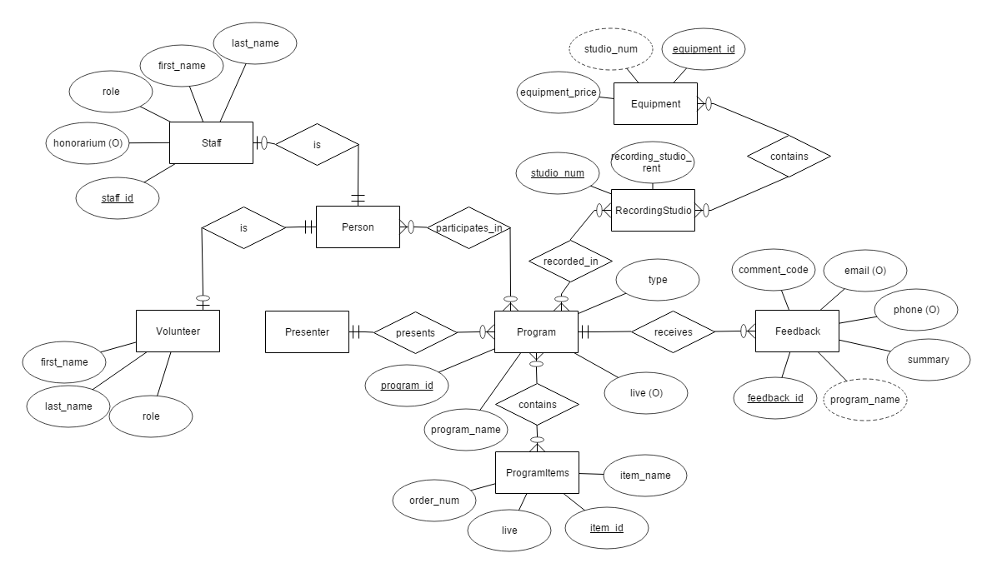

1. **Create a Conceptual Diagram (electronically) for the following scenario – this time DO NOT LEAVE the Many to Many relationships (break them out). Also, like the last scenario, make sure you identify the major attributes. Save the readable image and embed it back into this document.**

This scenario describes the activities of the Science and Technology faculty in a university in Utah. Students take courses in the university. The courses are run by departments. It is possible for a course to be run by more than one department. Each course consists of a number of units. Lecturers teach the units, and in some circumstances more than one lecturer will teach a unit. Lecturers of course teach on more than one unit. Since the introduction of 'modular' courses, it is possible for one unit to be included on more than one course. A lecturer may be a course leader for a particular course. 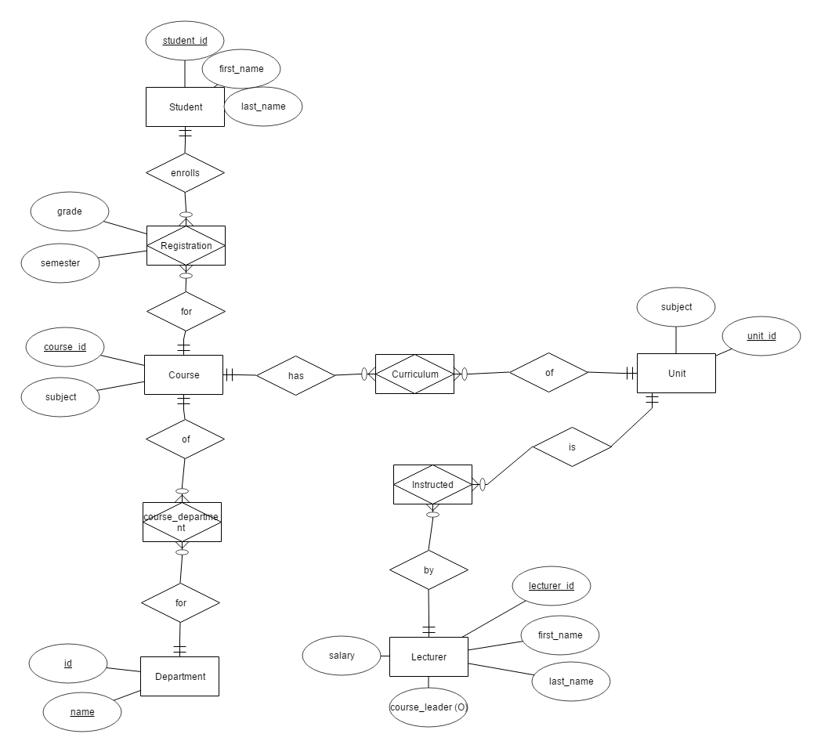

1. **Create a LOGICAL Diagram (electronically) for the following scenario. Use crow’s feet notation, and identity the major entity sets, their attributes, and relationships (with verbs). Save the diagram image and embed it back into this document.**

A farmer wishes to keep computerized records on the milk and calf production of the dairy herd. All calves produced are sold and not added to the dairy herd. Each cow has a name and date of birth, and will produce milk for a lactation period after the birth of a calf or calves. Milk recordings for each cow in terms of litres are taken each day. The information required for each pregnancy of a cow are the bull's name, date of mating, date of birth of calf or calves and each calf's sex and birth weight. The system is to provide the following information to the farmer:

• Details of all births of calves attributed to each bull

• Milk yield of a cow over a particular pregnancy (note: a lactation period is associated with each pregnancy)

